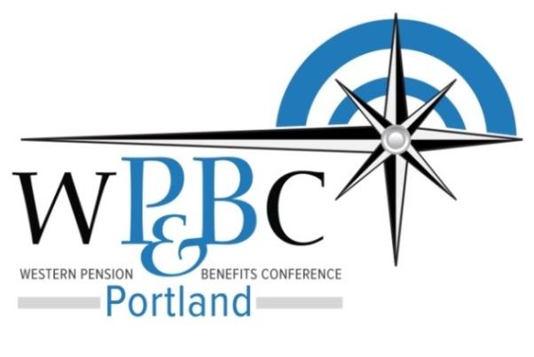

# REtirement plan Symposium

## Wednesday, January 14, 2015

8:30 AM – 11:30 AM Pacific Time

# Presenter Biographies

|  |  |
| --- | --- |
| Vincent Cacciottoli  Owner - Portland  X:\WP&BC\2015-01-14 Retirement Symposium\download.png  (503) 553-3181 [vcacciottoli@gsblaw.com](mailto:vcacciottoli@gsblaw.com) | Vincent Cacciottoli brings over 30 years of experience, knowledge and insight to bear in navigating employers through the complex laws that impact the design, operation and termination of employee benefit and executive compensation plans. Vince serves as an advisor to the boards, committees, trustees and key executives of private and public companies, financial institutions and nonprofit organizations.  Vince resolves compliance issues for retirement, health and welfare and executive compensation plans. He also negotiates the administrative and investment contracts and agreements for those plans, advises on fiduciary and directors’ and officers’ liability, corporate governance and plan investment issues, and he handles benefit and executive compensation issues in mergers and acquisitions.  Vince graduated from New York University with a Bachelor of Arts degree in 1972 as well as receiving a Juris Doctor degree from Fordham University School of Law in 1975.  Full bio available at: <https://www.gsblaw.com/professionals/vincent_p_cacciottoli/> |
| Chris Wolfe QPFC, APA  Retirement Plan Consultant  cid:image002.png@01CF1449.A3DFE040  (971) 321-7203 [chris.wolfe@standard.com](mailto:chris.wolfe@standard.com) | Chris Wolfe is a pension consultant in The Standard’s Pacific Northwest Retirement Plans sales office. He has 15 years’ experience servicing 401(k), 403(b), defined benefit, and 457 plans, consulting with financial service intermediaries and plan sponsors, and helping plan advisors deliver the most appropriate solutions for their clients’ needs.  Chris has been with The Standard since 2001 in a variety of retirement plans roles, and was formerly a regional wholesaler with Nationwide Financial. He holds the Accredited Pension Administrator (APA) from the National Institute of Pension Administrators (NIPA), and the Qualified Plan Financial Consultant (QPFC) from the American Society of Pension Professionals and Actuaries (ASPPA) designations. He also holds Series 6, 63 and 65 securities licenses, as well as the Life, Health, and Variable Products license in Alaska, Oregon, California, Washington, Idaho, Arizona, New Mexico and Nevada.  Chris graduated from Wittenberg University in Springfield, Ohio, with a bachelor’s degree in business administration. |
| Scott Faris JD, CFA  Senior Consultant  X:\WP&BC\2015-01-14 Retirement Symposium\Hyas Logo.png  (971) 634-1507 [sfaris@hyasgroup.com](mailto:sfaris@hyasgroup.com) | Scott Faris is a Senior Consultant for the Hyas Group where he is responsible for developing and managing institutional client relationships. He has over 24 years of experience providing fiduciary, investment, technical and educational advice to governmental, corporate and non-profit sponsors of retirement plans.  Prior to joining the Hyas Group, Scott served as Senior Consultant at Towers Watson Investment Services where he advised pension and defined contribution retirement plans ranging in size from $50 million to over $3 billion in plan assets. He also served as Managing Director at Arnerich Massena, Inc. in Portland, Oregon with oversight and service model delivery responsibilities for firm-wide services to retirement plan clients.  Scott graduated with honors from Montana State University with a Bachelor of Science degree in Finance as well as receiving a Juris Doctor degree from William Mitchell College of Law. He has also earned the Chartered Financial Analyst (CFA) designation and is a member of the CFA Institute.  Full bio available at: <http://www.hyasgroup.com/key-personnel.htm> |
| Jennifer Schuessler CFP  Regional Director  cid:image003.png@01CFFAA2.052328F0  (785) 383-1608 [jennifer.schuessler@great west.com](mailto:jennifer.schuessler@great%20west.com) | Jennifer Schuessler is responsible for marketing Empower’s corporate retirement plan services to intermediaries and plan sponsors. In her previous role as a Communications Program Manager at J.P. Morgan Retirement Plan Services, she was involved with the marketing and development of Audience of One® programs to external partners. Jennifer also served as a Communications Relationship Manager and Financial Education Consultant during her time with J.P. Morgan. Before joining J.P. Morgan, she served as a Financial Advisor in the Midwest.  Jennifer has a bachelor’s degree from the University of Kansas where she studied Business Administration and Spanish.  She also holds a Graduate Certificate in Personal Financial Planning from Kansas State University and holds Series 7, 63 and 65 licenses. Jennifer has nine years of industry experience and lives near Seattle, WA. |
| Monique Little  Chief People Officer    (503) 350-4504 [Monique.Little@firsttech fed.com](mailto:Monique.Little@firsttech%20fed.com) | Monique is a career Human Resources professional who oversees First Tech's HR, Employee Development, Internal Communications and Community Relations functions. A financial services veteran, she was also Vice President and Senior HR Partner with Columbia Management, the nationally recognized asset management firm.  Monique has a bachelor's degree from Oregon State University and is a certified Human Resources Professional (Human Resources Certification Institute). She's actively involved in professional and community organizations, and served as a past member of the Portland Children's Museum Board's HR and Finance Committee. She is also Past President of the Northwest Human Resource Management Association (NHRMA), Past Director of the Oregon State SHRM Council, and is an active TechAmerica HR Committee member. She's also a past recipient of the NHRMA Distinguished Member Award. |
| Kevin Raymond  Director, Co-founder  P:\Templates - Sellwood\Logo\sellwood_logo.jpg  (503) 596-2880 [kevinraymond@sellwood consulting.com](mailto:kevinraymond@sellwoodconsulting.com) | Kevin Raymond serves as a Director of Sellwood Consulting LLC and co-founded the firm.  He sits on Sellwood’s Board of Directors and Investment Committee. Kevin has led investment consulting relationships for endowments and foundations, corporate pension and defined contribution plans, health care and operating reserve portfolios ranging in size from approximately $3 million to $5 billion.  Prior to co-founding Sellwood Consulting LLC, Kevin was a Consultant and Principal at R.V. Kuhns & Associates, also serving as a co‐leader of their Defined Contribution Solutions Group, an internal resource for defined contribution plan design and construction and providing guidance for the firm’s defined contribution advisory practice.  Kevin earned an MBA from the Duke University Fuqua School of Business, graduating as a Fuqua Scholar. He also earned a BA in Economics from Middlebury College, graduating Summa Cum Laude and Phi Beta Kappa. Kevin is a member of the CFA Institute and the CFA Society of Portland.  Full bio available at: <http://www.sellwoodconsulting.com/team/kevin-raymond/> |